**Homework #5:**  Due February 27 @ 4:00 PM

1. Use the *random* Python module to determine the length of a side of a regular hexagon. Construct the remaining sides using different colors.

2. Construct a circle with a circumference of varying thickness.

3. An aimless hedgehog makes a random turn and then takes 100 steps forward, makes another random turn, takes another 100 steps, turns another random amount, etc. A student records the angle of each turn before the next 100 steps are taken. Her experimental data is [160, -43, 270, -97, -43, 200, -940, 17, -86]. (Positive angles are counter-clockwise.) Use a turtle to draw the path taken by our unpredictable friend.

4. Spell WSPS using functions for the letters.

* Each letter should be at least 100 pixels tall and 50 pixels wide.
* Each distinct letter should be a different color (if a letter repeats, it can have the same color).

5. Write a program to draw a shape like this:

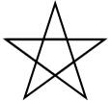

Hints:

* + Try this on a piece of paper, moving and turning your cellphone as if it was a turtle. Watch how many complete rotations your cellphone makes before you complete the star. Since each full rotation is 360 degrees, you can figure out the total number of degrees that your phone was rotated through. If you divide that by 5, because there are five points to the star, you’ll know how many degrees to turn the turtle at each point.
  + You can hide a turtle behind its invisibility cloak if you don’t want it shown. It will still draw its lines if its pen is down. The method is invoked as tess.hideturtle() . To make the turtle visible again, use tess.showturtle() .

6. Write a program to draw a face of a clock that looks something like this:

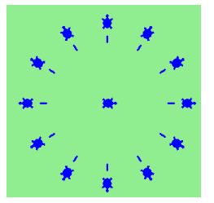 Hint: Using functions may simplify your work